Hypothesis Testing and Stock Returns

**Contents**

1 Case Study Data 2

2 Daily returns 3

3 Student’s T test results 3

4 Conclusion 4

# Case Study Data

S&P 500 index (^GSPC) and random 10 component stocks data for last year were downloaded from Yahoo! To calculate returns the data were converted into time series.

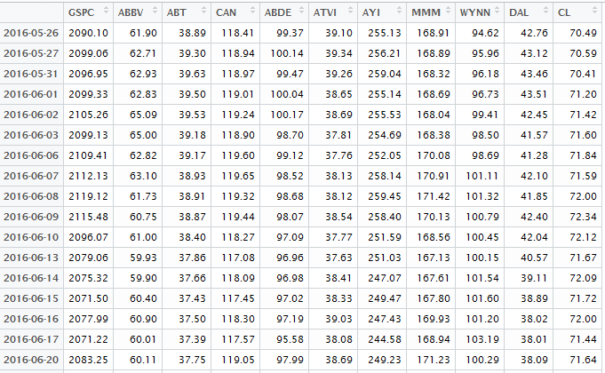

Figure 1 - Time series for index and 10 stocks

# Daily returns

The second step was to calculate daily returns for the index and 10 underlying stocks. For this purpose **Return.calculate( )** function from library “**PerformanceAnalytics**” was used.

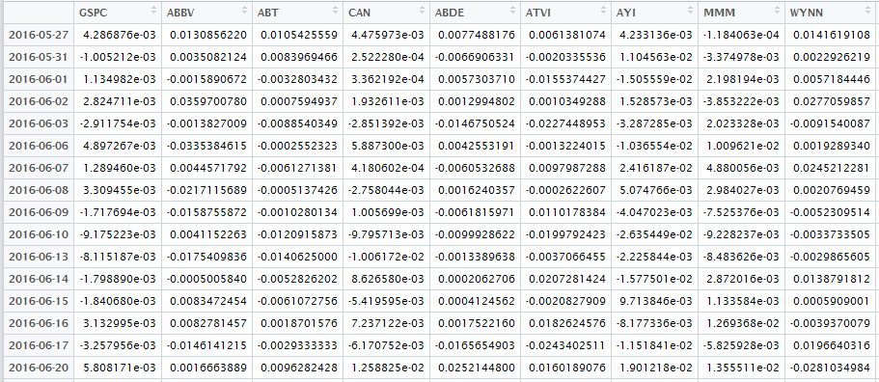

Figure 2 - Daily returns

# Student’s T test results

For each of the selected stocks and the index Student’s T test was performed. For this purposed **t.test( )** function was used. The Null Hypothesis was that the mean daily stock return is zero. Based on collected p-values and t-values conclusion was made. Two result vectors for p-values and t-values are represented below:

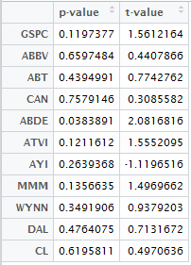

Figure 3 - p-values and t-values

As we can see, H0 is rejected only once (0.0383891 < 0.05).

# Conclusion

Based on t-values the next conclusion can be made: the index and 9 out of 10 stocks demonstrated a positive tendency and only one (AYI) – negative one (t-value = -1.119616 < 0).

At the same time, p-values say that index and all stocks except ABDE changed negligibly when only ABDE grew significantly (p-value = 0.0383891 < 0.05 that means that H0 is rejected with level of significance = 5%).

Regarding to extrapolation, S&P 500 is capitalization-weighted that means that companies which are relatively small influence much less the whole picture. According to this fact, randomly selected stocks could have considerable different result. Moreover, the number of randomly chosen stocks is also essential factor: 10 out of 500, in my opinion, is not enough.